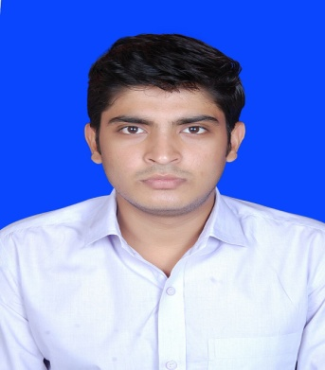
Vishal singh
Mobile : +91 9892317198
Email : vishalsingh121296@gmail.com

Objective:
Seeking a challenging and rewarding opportunity with an organization of repute which recognizes and utilizes my true potential while nurturing analytical and technical skills

Academia:
- B.Sc.IT in year 2016 with 70% from Thakur College of Science And Commerce(Mumbai University)
- HSC in year 2013 with 78%, from Jaunpur, Uttar Pradesh.
- SSC in year 2011 with 80%, from Jaunpur, Uttar Pradesh.

Academic Triumphs:
- Best Cricket player of the year 2010.
- Active participation in various competitions at school & college level.

IT Skills:
- Programming Languages: Java (J2SE, Servlets, JSP, JDBC,ODBC, EJB), Struts, Spring, HTML, XML, JavaScript, Basic Knowledge of Android
- Databases: MYSQL, MS SQL Server
- Design & IDE Tools: NetBeans, Eclipse, Visual Studio, Android Studio
- Operating Systems: Windows 7/XP/8,Ubuntu

Projects:

Blood Bank Management System (Technology-Java, JavaScript, MYSQL)

- This project aims at maintaining all the information pertaining to blood donors, different blood groups available in each blood bank and helps them manage in a better way.

Private Carpooling System (Technology-Java, Android studio, MYSQL)

- Carpooling system is a network based application that is aimed towards creating highly affordable and environment friendly private transport system.
- The application provides the Passengers a platform to avail private cars for their Journey from certain point.
- Application seamlessly integrates itself with the Driver by providing him real-time information about its passengers without wasting time and resources.
Work Experience:
- Fresher

Certifications/Courses:
- Java Certified from Seed InfoTech
- Cambridge English Entry Level Certificate in ESOL International(Entry 1)*
- Certificate of Appreciation(IT Live 2.0 Organized by SEED InfoTech Ltd.,)

Personal Minutiae:
Age : 21 Yrs.
Gender : Male
Languages Spoken : English &Hindi
Nationality : Indian
Marital Status : Unmarried
Hobbies : Playing Cricket, Reading Books about astronomy
Address : B/306 Upvan Housing Soc. Mira-Bhy Road Miraroad(E) Mumbai-401107

Date:
Place: Vishal Singh

